Directions: In the chart below, fill in the number of each color that your bag of M&M’s contains. Then answer the following questions.
Color | Quantity
Blue
Green
Orange
Brown
Red
Yellow
TOTAL

- What is the ratio of red to orange?

- What is the ratio of yellow to green?

- What is the ratio of blue to the total number of M&M’s?

- What is the ratio of the total number of M&M’s to brown?

- Suppose you had another bag of M&M’s that contained twice the amount of M&M’s you have in this bag. How many green M&M’s would it need to have in order for you to have the same proportion of that color?

- Suppose you had yet another bag of M&M’s that contained 100 M&M’s! How many orange M&M’s would it need to have in order for you have the same proportion of that color?

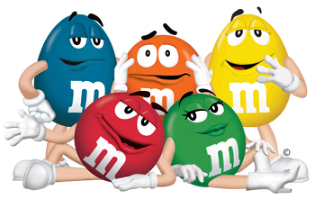

- Have each person eat three M&M’s of any color.
  - What is the ratio of yellow to the total?

  - What is the ratio of the total to red?

  - What is the ratio of blue to brown?

